

**North South University**

Project Report

Course: CSE427

Section: 1

Semester: Spring 2019

Instructor: Shaikh Shawon Arefin Shimon

Submission Date: 30 April 2019

|  |  |
| --- | --- |
| **Name** | **Id** |
| Md. Amdadul Bari | 1510813042 |
|  |  |

**Abstract** **3**

**System Architecture** **3**

**Input Space Partitioning:** **4**

Table of Input Space Partition: 4

Example of Input Space Partition: 5

Annotation used for Input Space Partition: 6

Example of Input Space Partition from Code: 6

**Graph Partitioning** **8**

UI Testing **10**

# **Abstract**

Krishok is an IoT based farming solution for Bangladeshi farmers to grow better amount of crops with better quality. Another outcome of this project is to help the farmers to face any kind of unknown condition which they did not face in their farming life. The whole system is automated where the device will notify the the suggestions to the farmers by analysing the data which it will get from it’s sensors, cameras, learning, and analytical capability. The system will also help the farmers by suggesting and predicting which types of crop will be helpful for attaining better profit under the range of options. It will also guide a farmer towards a good solution of that crops. The future scope of the project is, it will open job opportunity with a minimum budget but maximum profit in reply. The opened job opportunity of the project will be for those people who have a little technical knowledge.

# **System Architecture**

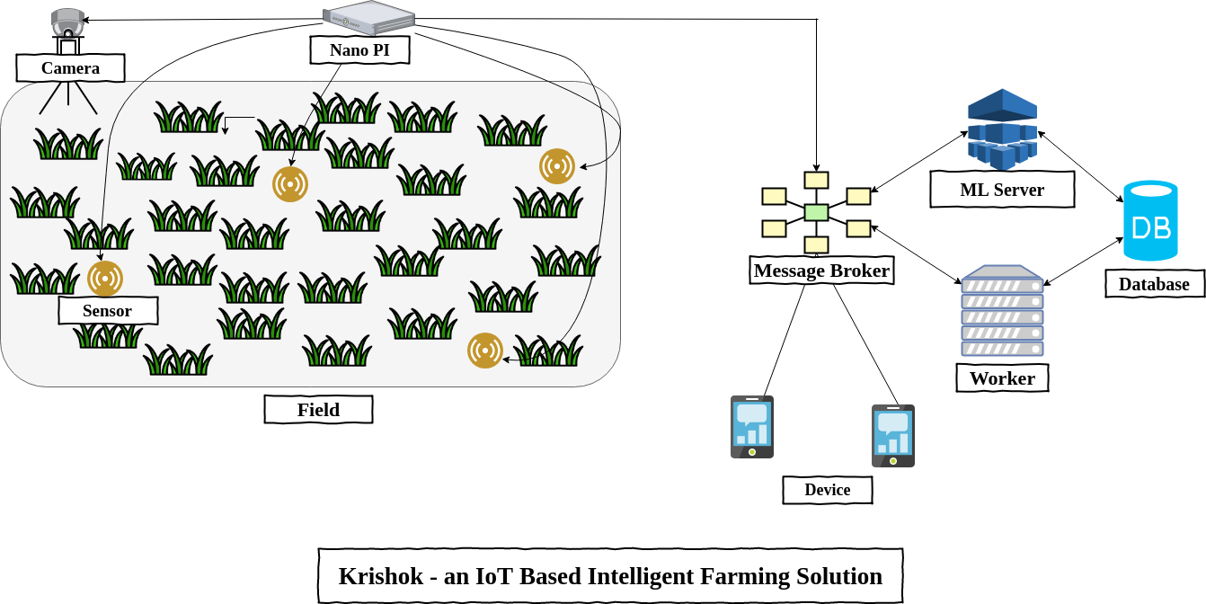

Fig 1 : System architecture of KrishokIoT

The system is controlled by a raspberry pi. Some sensors are connected with the raspberry pi, and the pi collects data from the sensors and sends the data to the worker. The worker will process those data, insert them in the database if needed and send some of the data to ML servers. Then the ml servers send the response back to the worker and the worker sends back the data to the pi and other connected android devices of the farmer as a command, alert or report. For keeping the communication stable and lightweight MQTT protocols has been used and to stream the video to the cloud , we have used WebRTC based Kurento Media Server.

# **Input Space Partitioning:**

Mainly these four type of data type is used in the backend of the system. For the types input spaces are partitioned as the following table.

### Table of Input Space Partition:

|  |  |
| --- | --- |
| Data Type | Block |
| Integer | Positive Number |
| Negative Number |
| Zero |
| Double | Positive Number |
| Negative Number |
| Zero |
| Float | Positive Number |
| Negative Number |
| Zero |
| String | Empty and only space |
| Small Text |
| LargeText |
|  | Null |

### Example of Input Space Partition:

|  |  |  |
| --- | --- | --- |
| Data Type | Range Type | |
| Integer | Positive Number | 1,100,150 |
| Negative Number | -1500,5233 |
| Zero | 0 |
| Double | Positive Number | 11.22,25.22 |
| Negative Number | -58.22,85.55 |
| Zero | 0 |
| Float | Positive Number | 55.5f,5589.245f |
| Negative Number | -98.69f,-69.55f |
| Zero | 0.00f |
| String | Empty and only space | “” , “ “ |
| Small Text | “NSUCSE427” |
| LargeText | “aaaaaaaaaaaaaaaaaaaaaaaaaaaaaaaaaaaaaaaaaaaaaaaaaaaaaaaaaaaaaaaaaaaaaaaaaaaaaaaaaaaaaaaaaaaaaaaaaaaaaaaaaa” |
|  | Null | null |

### 

### Annotation used for Input Space Partition:

1. Parametrized
2. Theory
3. Data Point
4. Test
5. Before - After
6. Setup

### Example of Input Space Partition from Code:

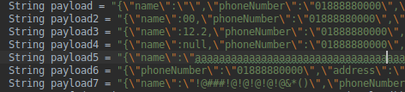

Fig 2: Input Space Partitions

Above code is a part of test method [Class: UserDaoTest - Line:55] of Valid/Invalid username checker. We can see in the string different types of value for the name key is present. Almost all possible type inputs are given to check whether the method execute successfully every time or not.

The test methods are implemented in seperate functions to keep the simplicity of the code.

This type of test cases are used in all test methods.

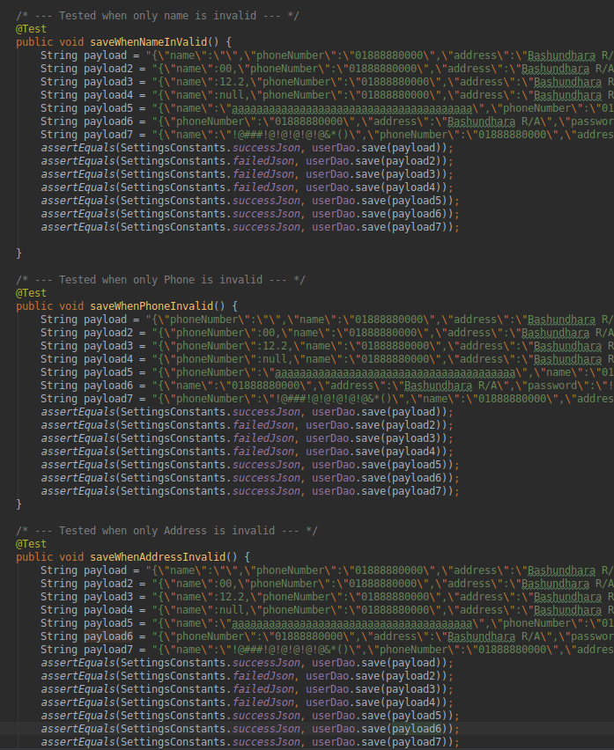

Fig 3: Input Space Partitions

# **Graph Partitioning**

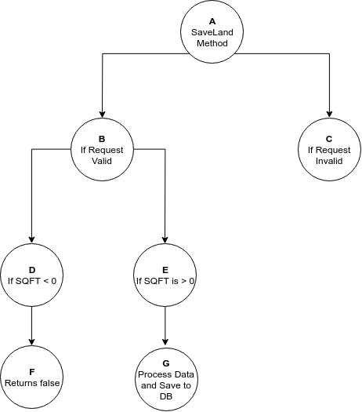

Fig 4 : Graph of Land Save method

It is a graph of a land saving api of the backend of this project. If the API gets any valid hit then it goes deeper and check the body of that request. After that if it found that the the square feet parameter is less than zero then it immediately returns false ,

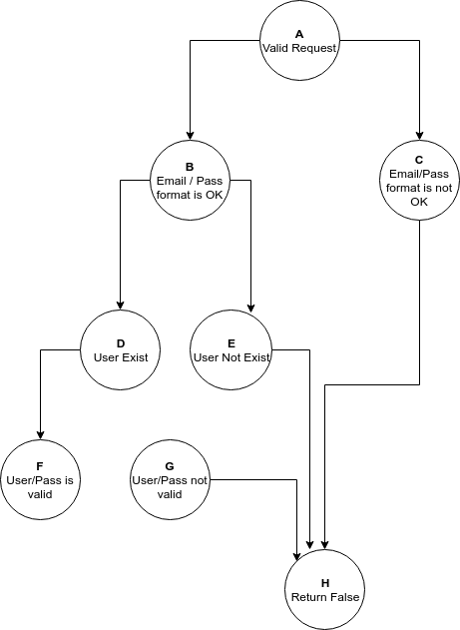

Fig 5: Graph of Login Feature

Fig 5 is the graph of login module of the API. If the API gets any valid hit in the login endpoint then it checks whether the email and password format is right or not. If it is right then it checks whether the user exists or not as shown in the graph.   
If the user exists then it checks if the user/pass combination is valid. If valid it logged in the user, otherwise declines the request.

# **UI Testing**



Espresso is a testing framework for Android to make it easy to write reliable user interface tests. Espresso test has been used to test action with the user interface. It also allows the test wait until all background activities have finished. It comes with the android studio .It is used in this project because it is very stable and easy to use.